Etana Disasa: Lab 2

Part 1

* 1. VirtualBox
  2. Vagrant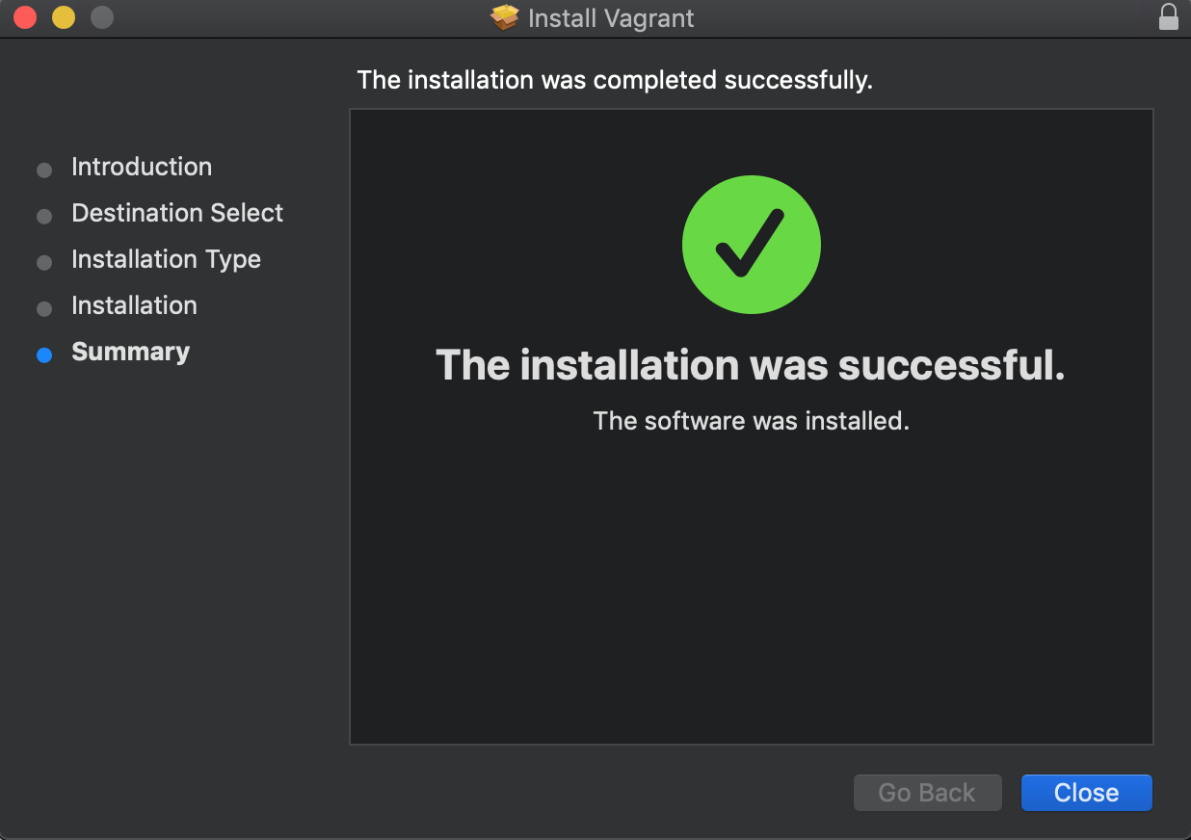
  3. Host Scripts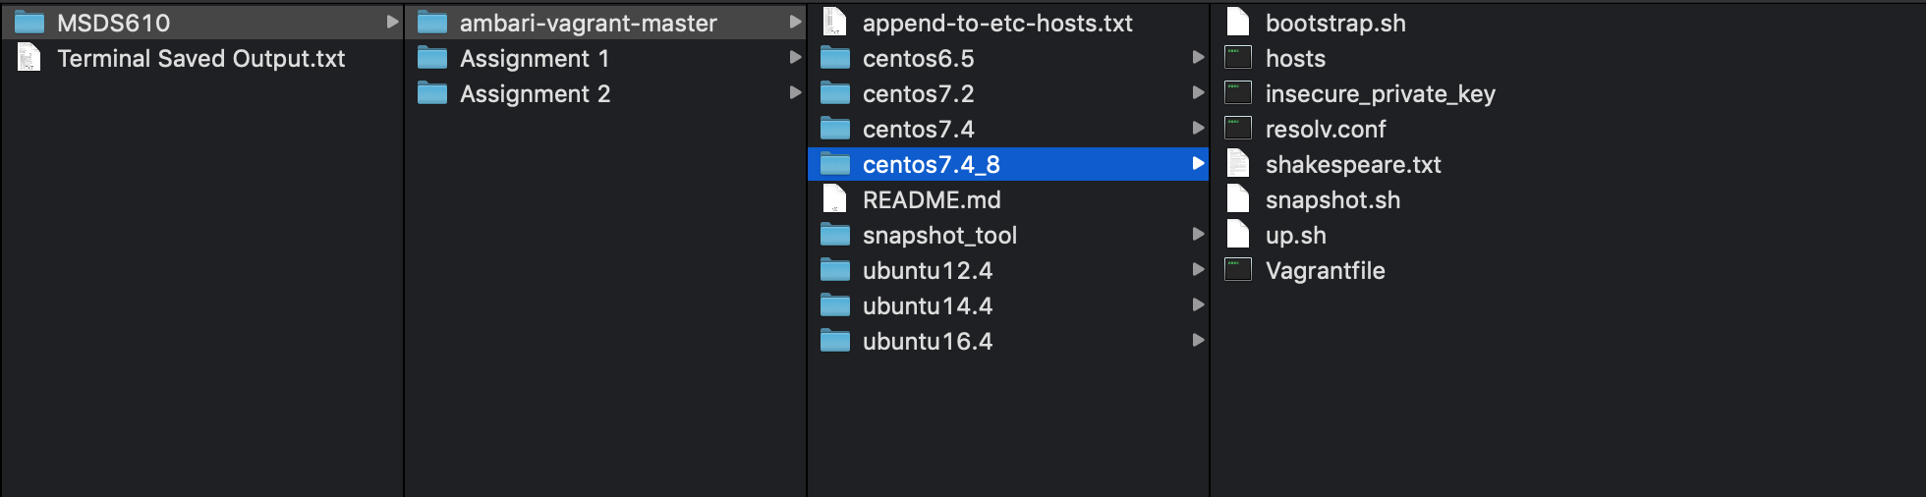
  4. Hosts File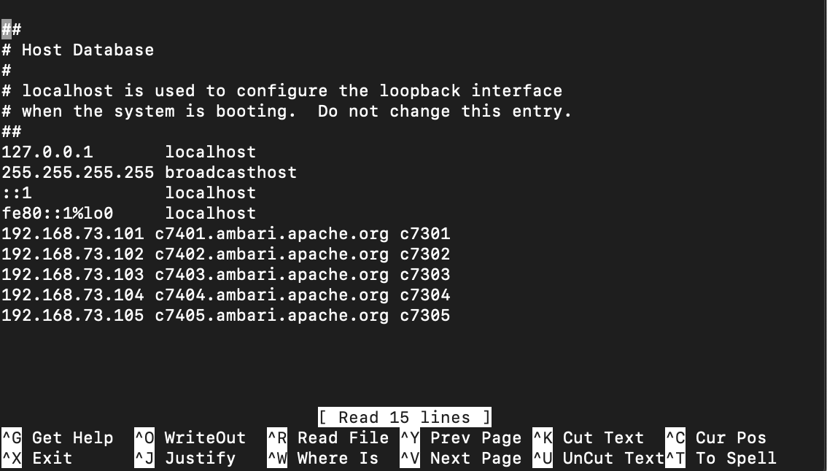
  5. Booting VMs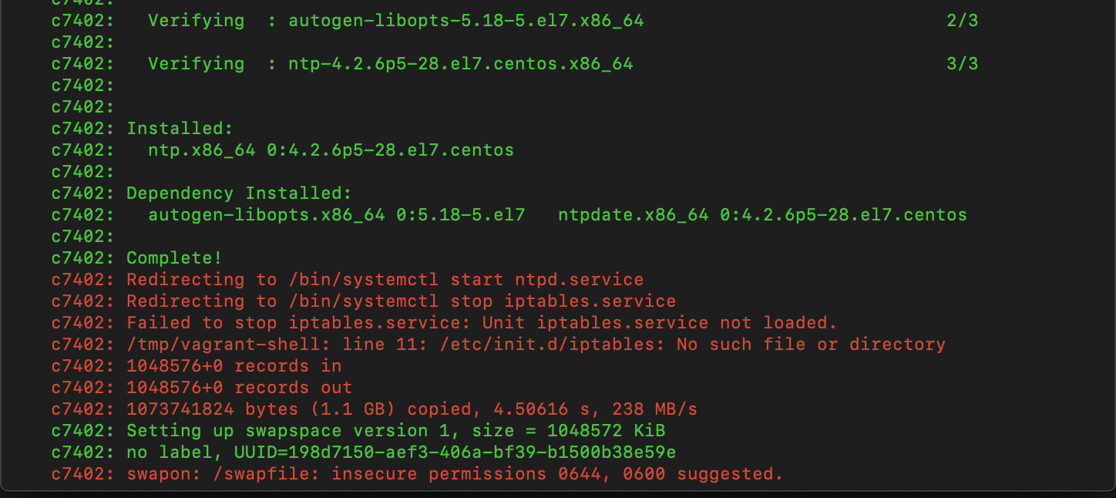

Part 2

* 1. Installing Ambari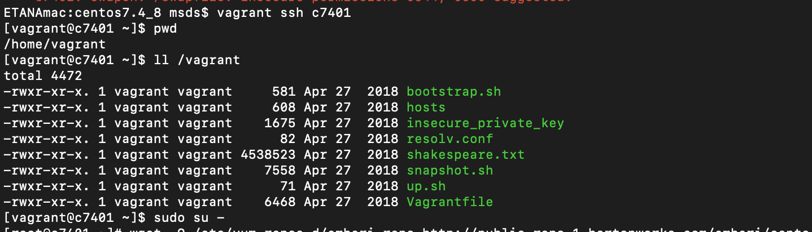

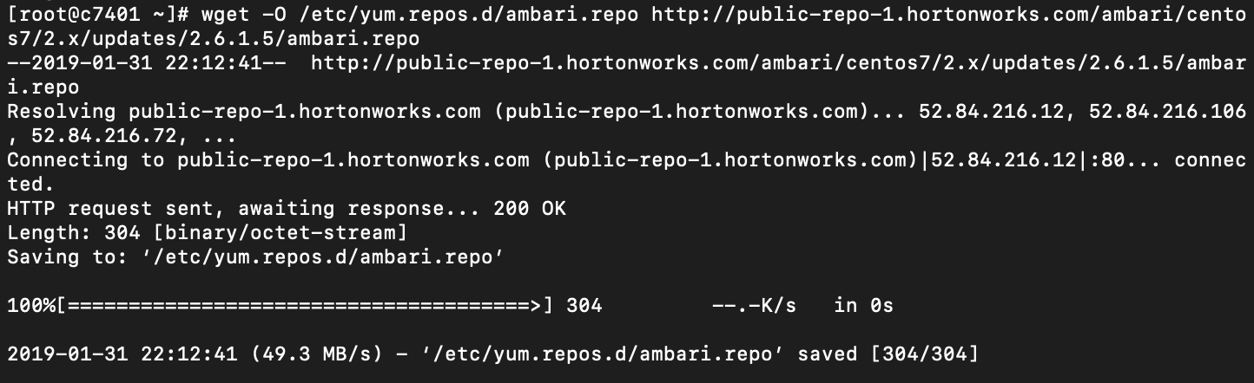

yum install -y ambari-server

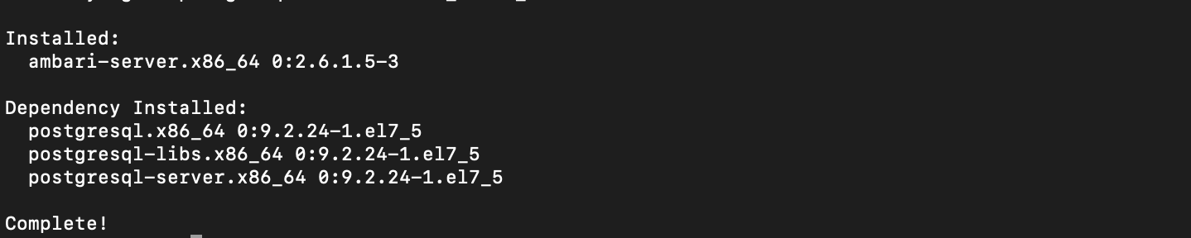  
  
ambari-server setup -s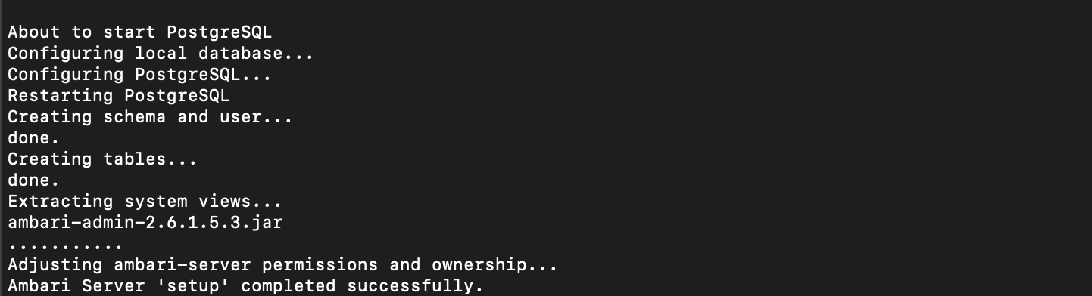

* 1. Installing MySQL Database and Connector  
     yum install -y mysql-connector-java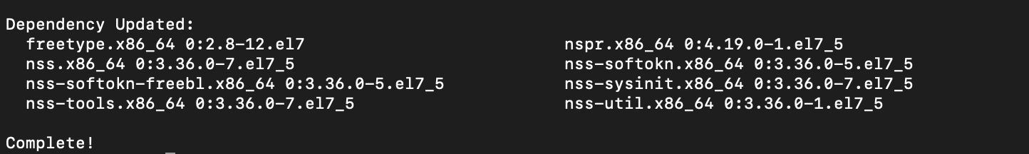  
     ambari-server setup --jdbc-db=mysql --jdbc-driver=/usr/share/java/mysql-connector-java.jar  
     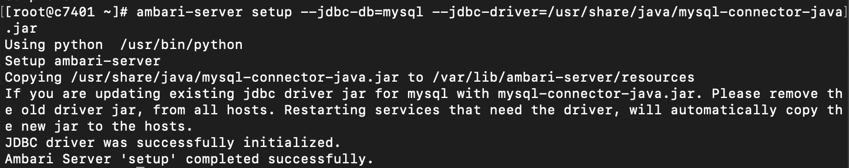  
     Putting MySQL on c7402.  
     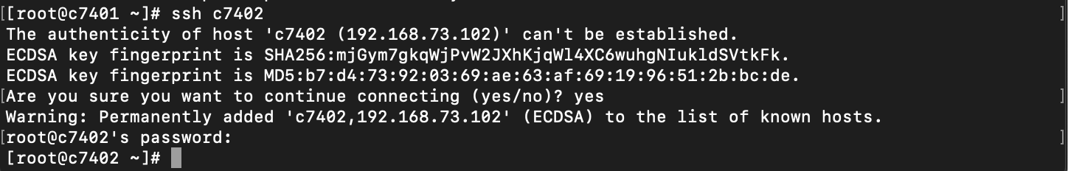  
     wget http://repo.mysql.com/mysql-community-release-el7-5.noarch.rpm  
     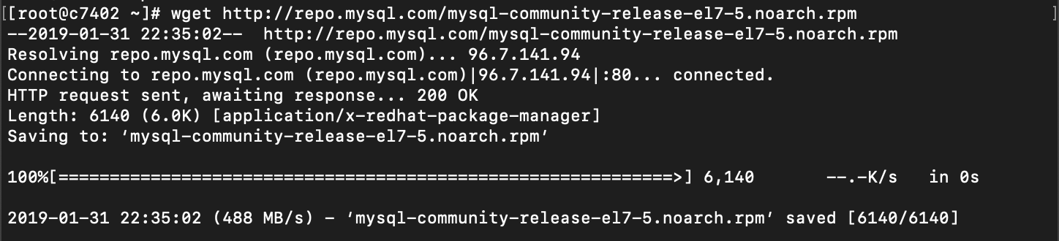  
     rpm -ivh mysql-community-release-el7-5.noarch.rpm  
     
  2. Start the Server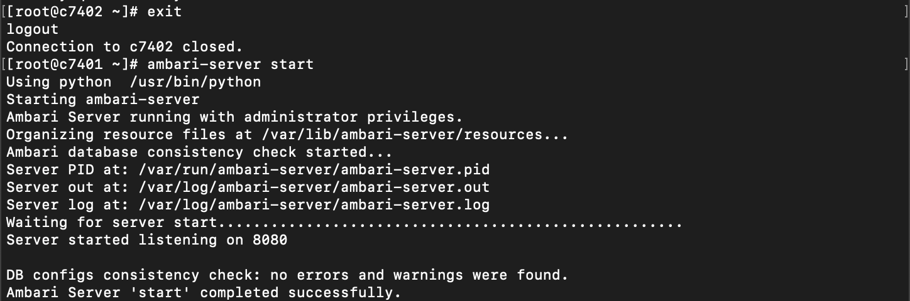

Part 3: Starting the Ambari User Interface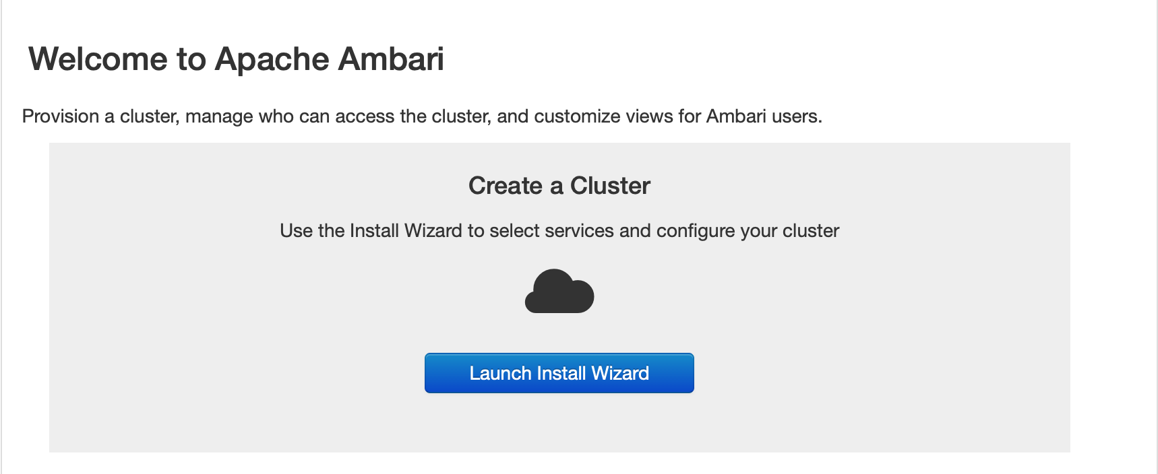

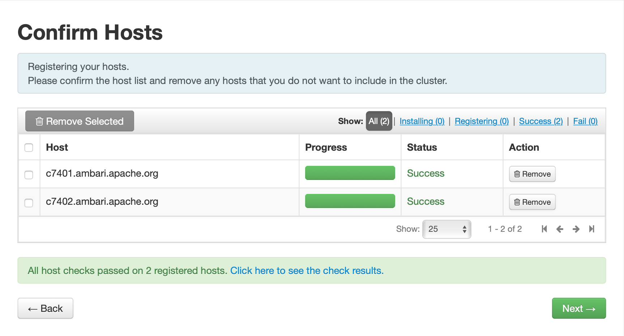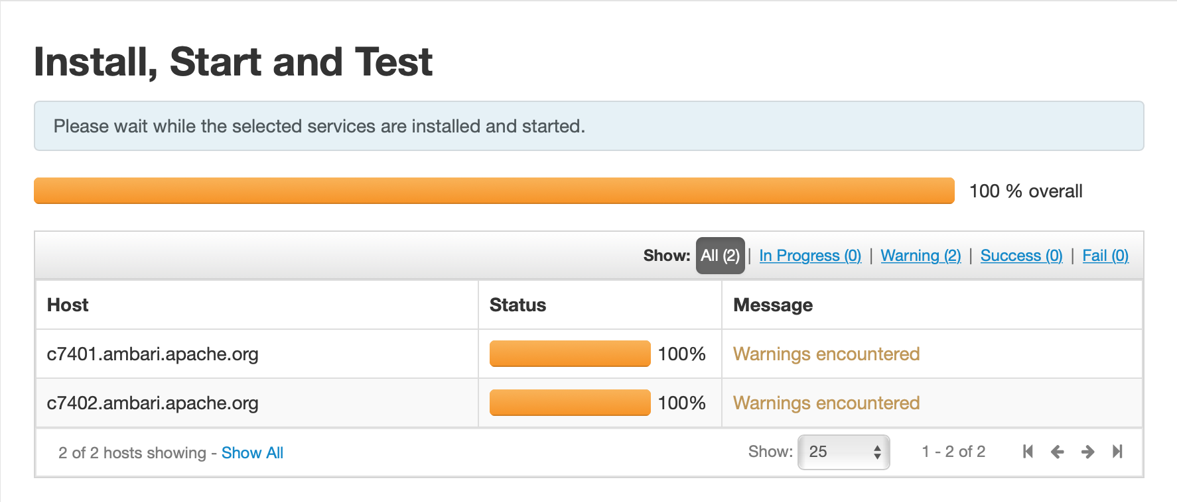

Silent download

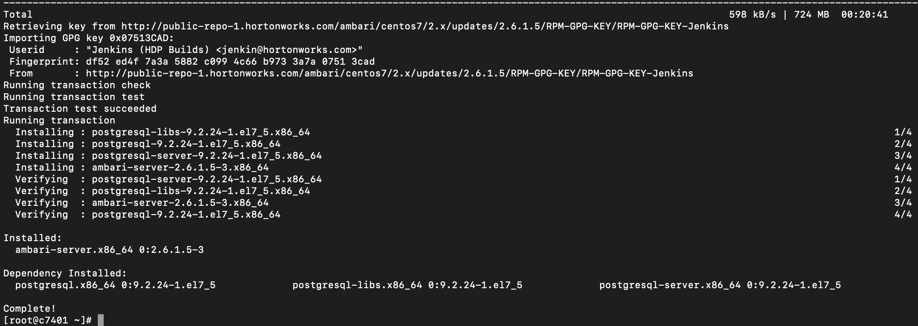

mysql



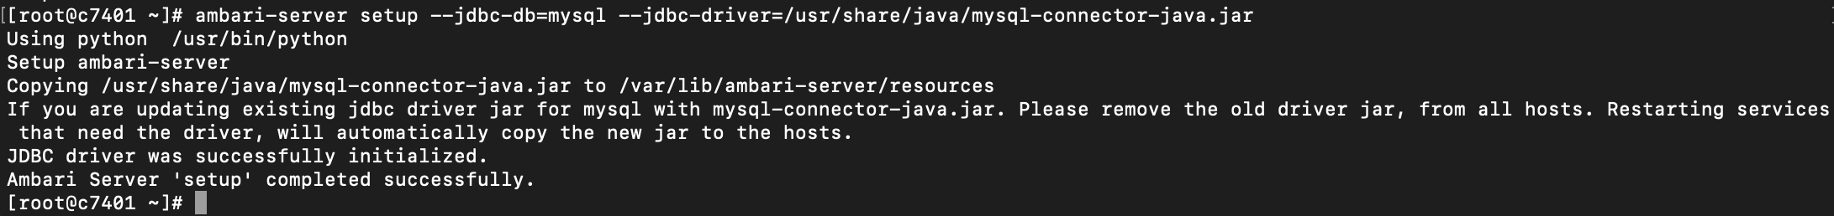

Sdsd

C740[1-2]

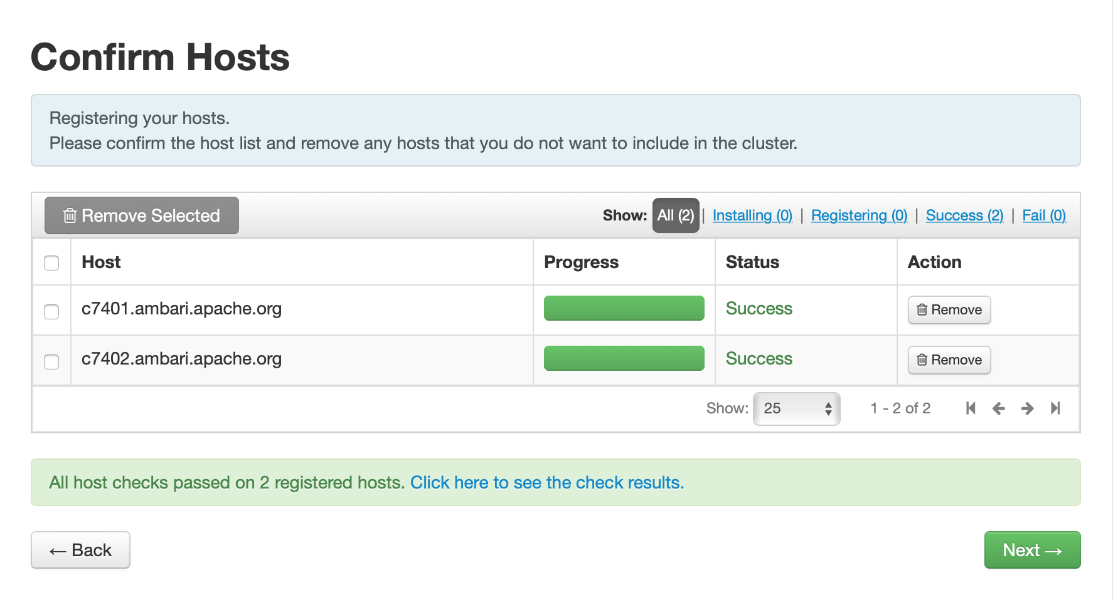



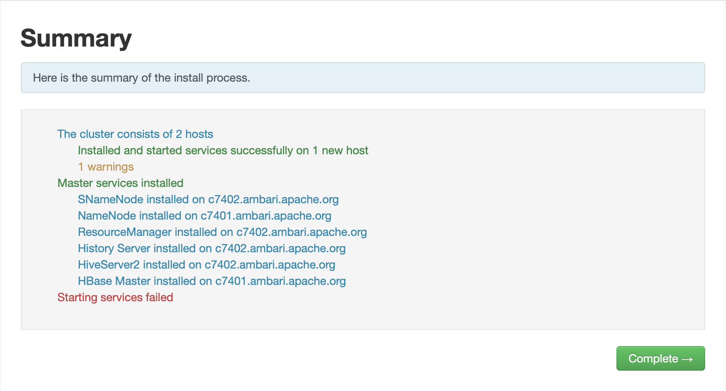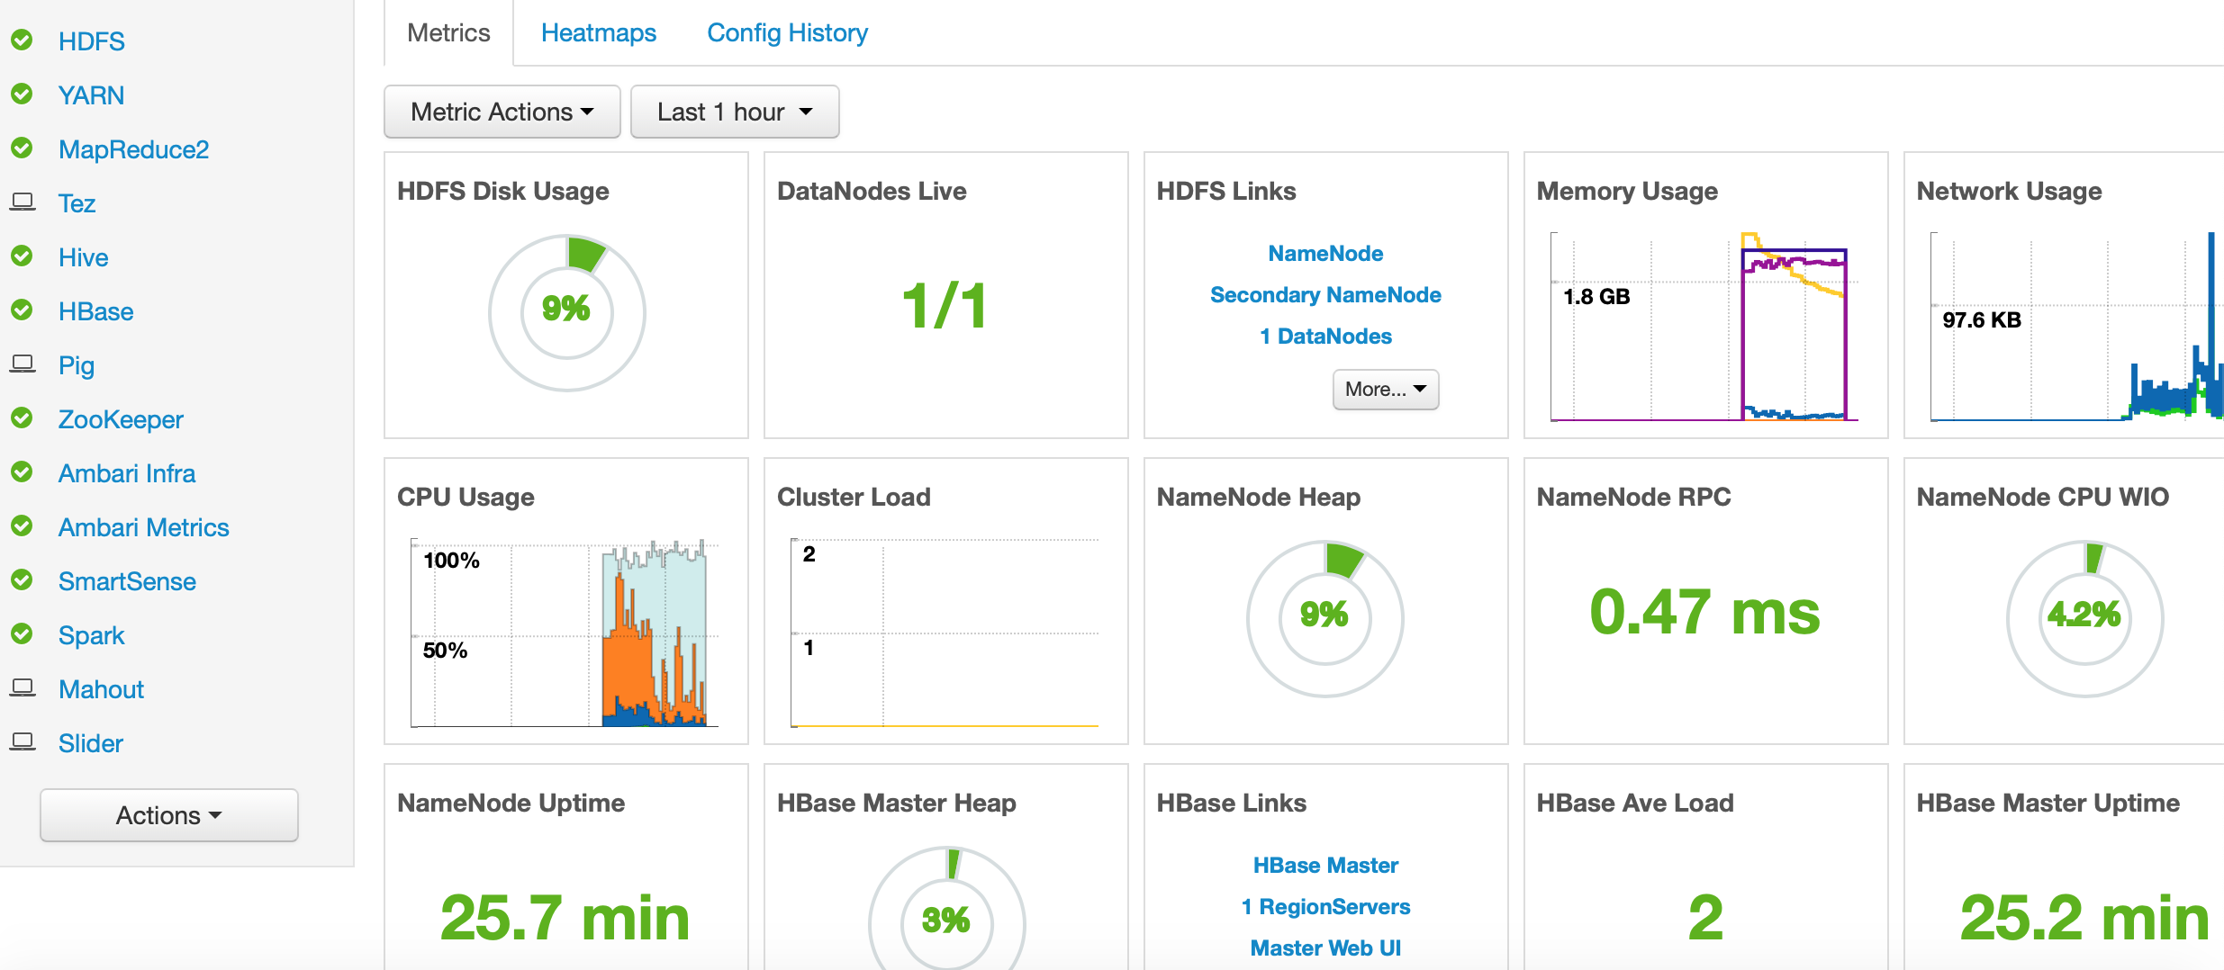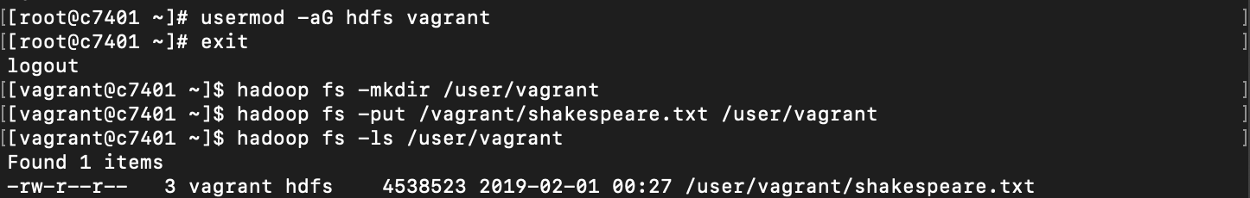



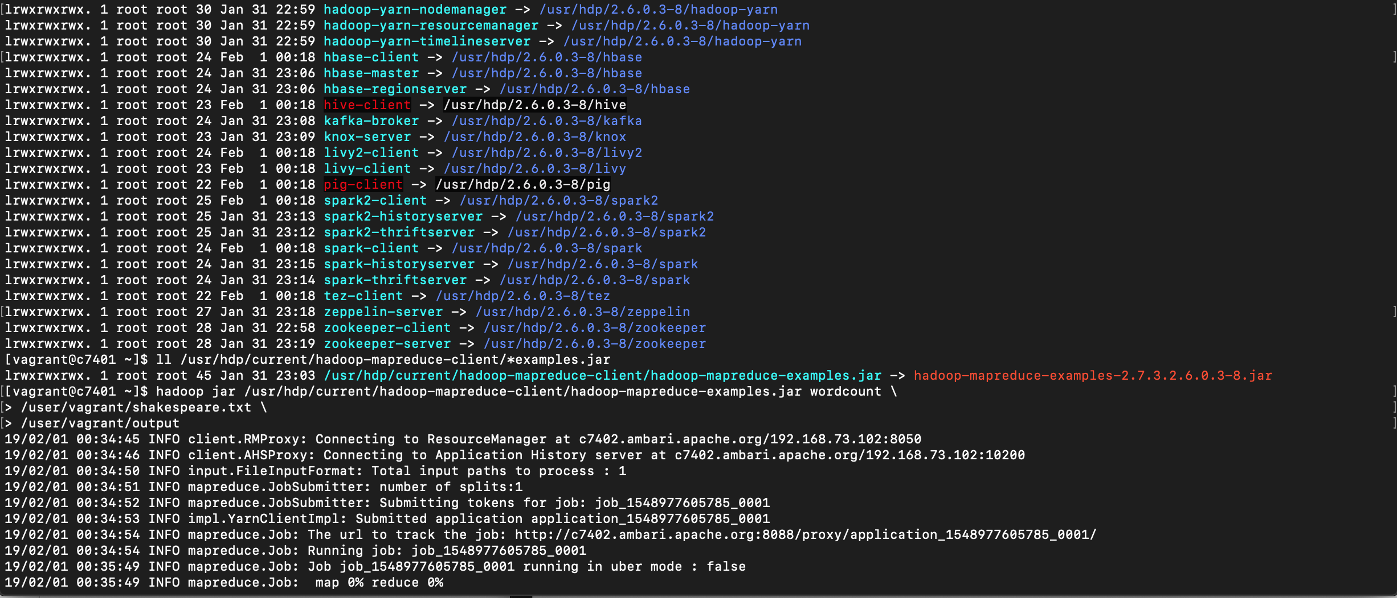

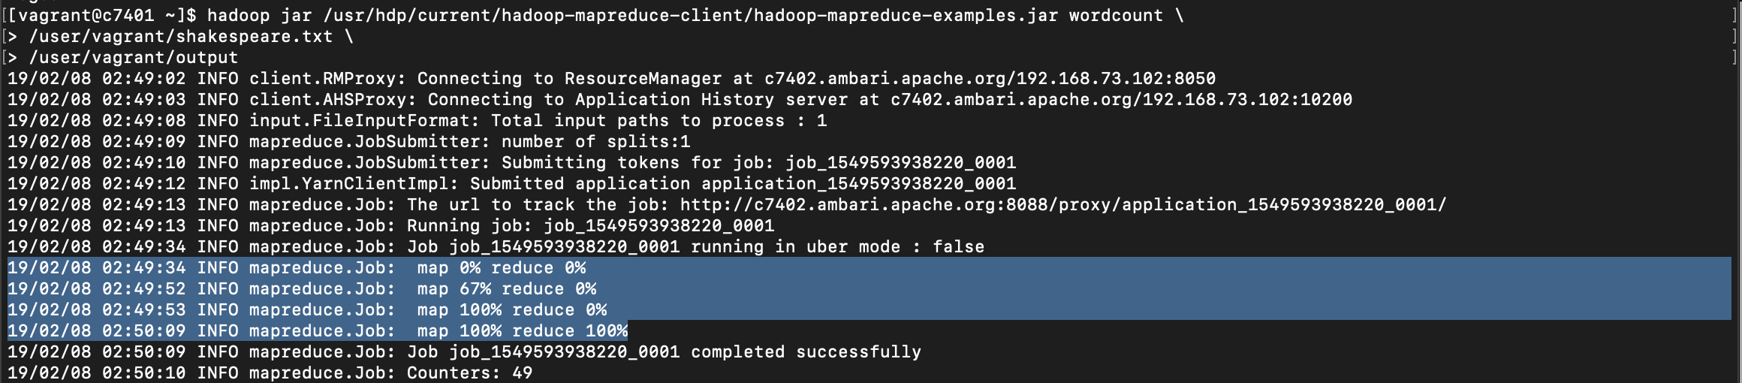







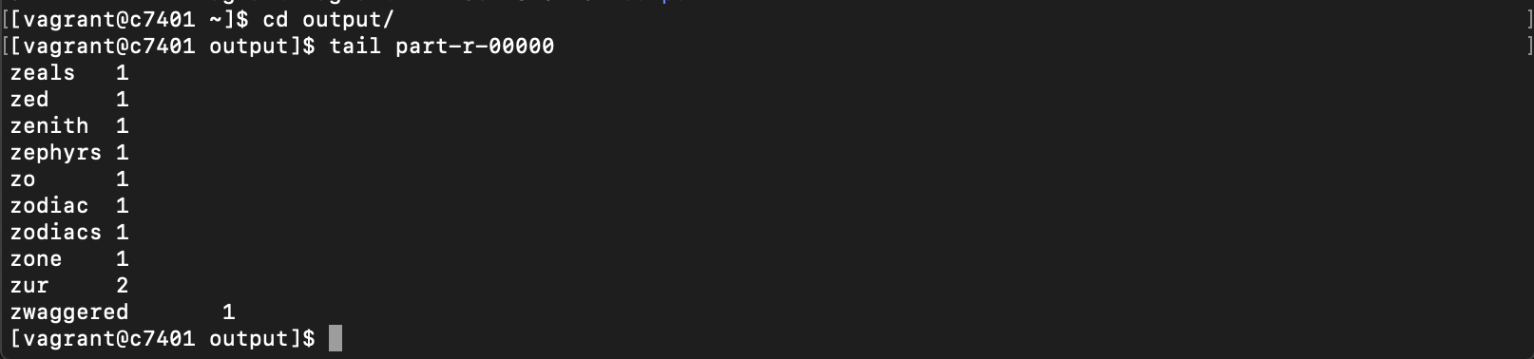

**Steps you found challenging and resolutions.**

After I have completed installing the Ambari platform and installed the cluster, getting the MapReduce of Shakespeare.txt was impossible for me. I do not know if it was from the size of my machine or if there was an issue with the installation.

In order to solve this problem, I removed the VMs and redone the entire process over 7 times. I have tried to change the ambari versions installed, I tried to create a new profile and re-installed VirtualBox and did the lab but none of these attempts produce a different result.

UPDATES: I was able to resolve the problem. It was a memory problem with the mapreduce services. Originally the memory allocated for Map and Reduce memories was 170MB. I changed that to 0.5GB and to 0.5GB consecutively as shown below. And the MapReduce process was able to complete.

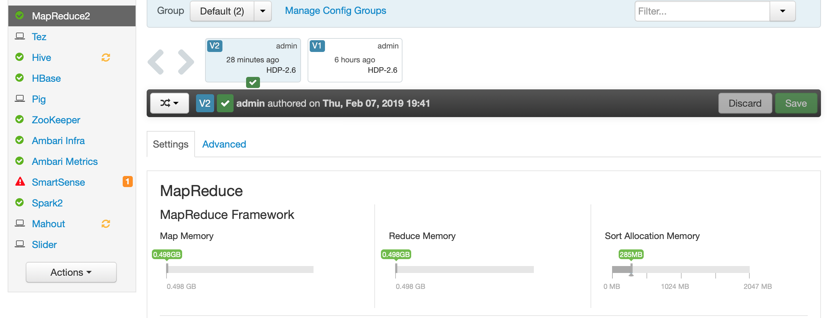

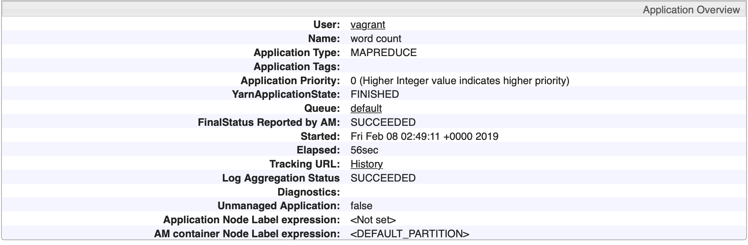

**Lessons learned**

During this process, I was able to learn command lines are case sensitive.

Eg. -O vs -o, -aG vs -ag

I have also witnessed how the different services within the cluster work together.

Another big lesson was that users and groups are very important in executing lines of codes.

Yet another big lesson was keeping the VMs in suspend mode saves the state.

Stopping all services before suspending VMs and starting after VMs are up to avoid loss of heartbeats.

I have learned that memory settings can significantly affect whether an application runs or not.

I have learned that <http://c7402.ambari.apache.org:8088/cluster/apps> produces the list of all applications that are running with their logs and status.

These were some of the lessons I learned.